**IMS - GISC Operator Manual**

1．How to login As External User

**Step 1:**

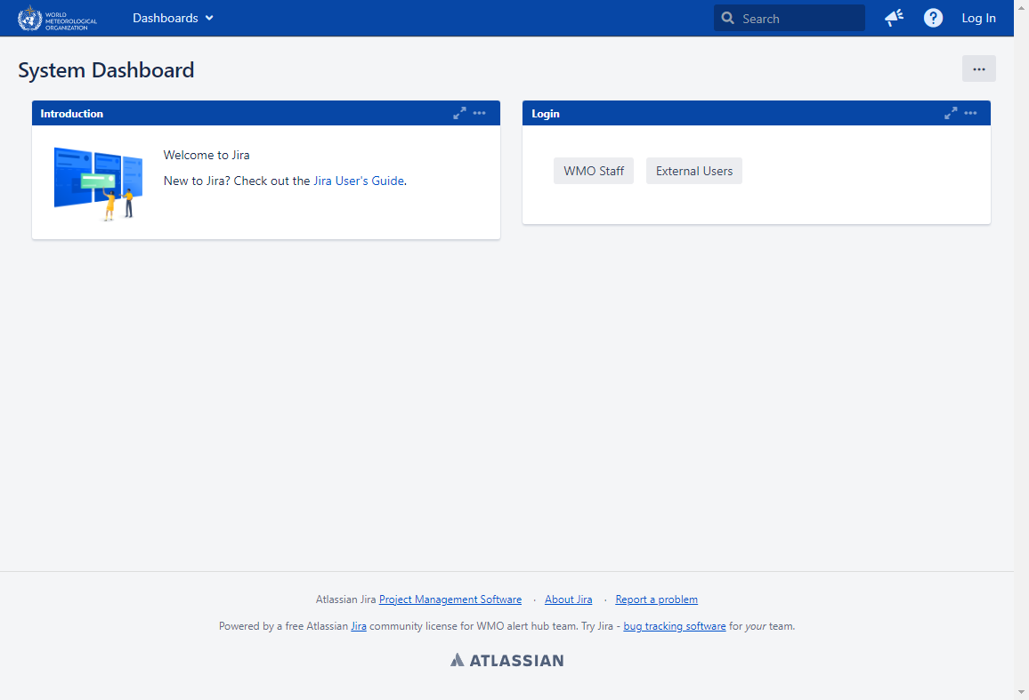Access the login url **https://jira.wmo.int/secure/Dashboard.jspa**

**Step 2:**

Click on **External Users** Button

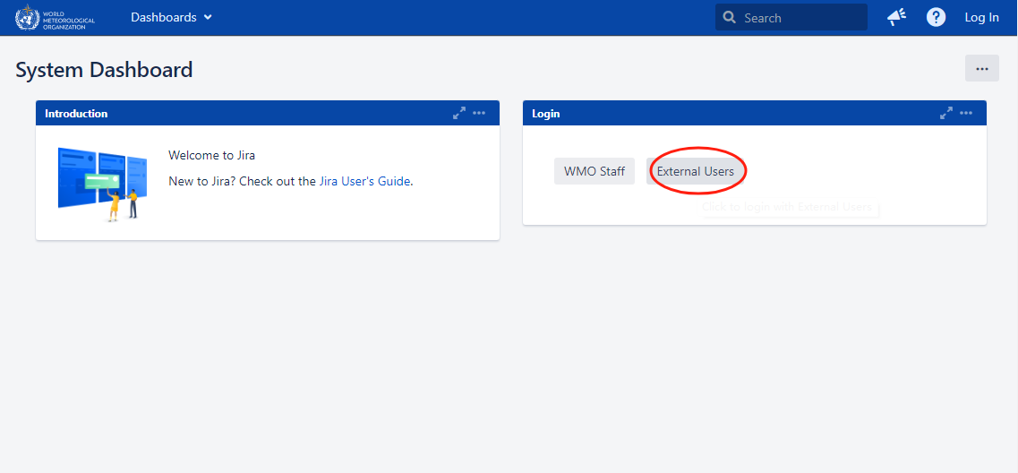

**Step 3:**

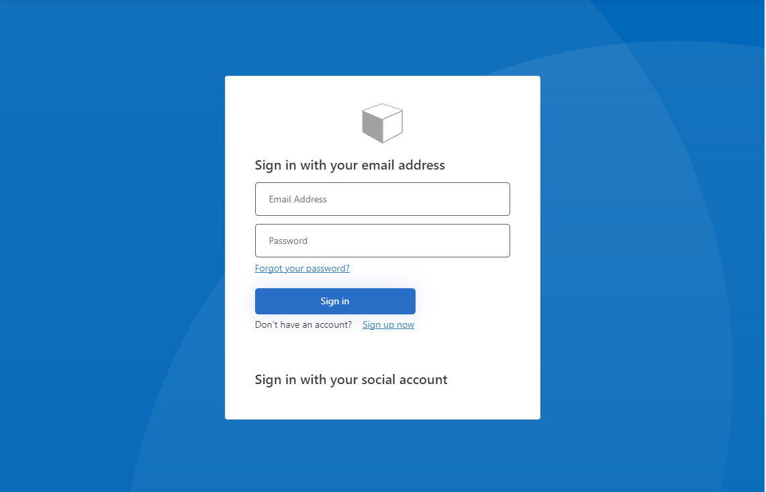You will be redirected to login page to write your email and password added in our database.

1. How to resolve issue

**Step 1:**

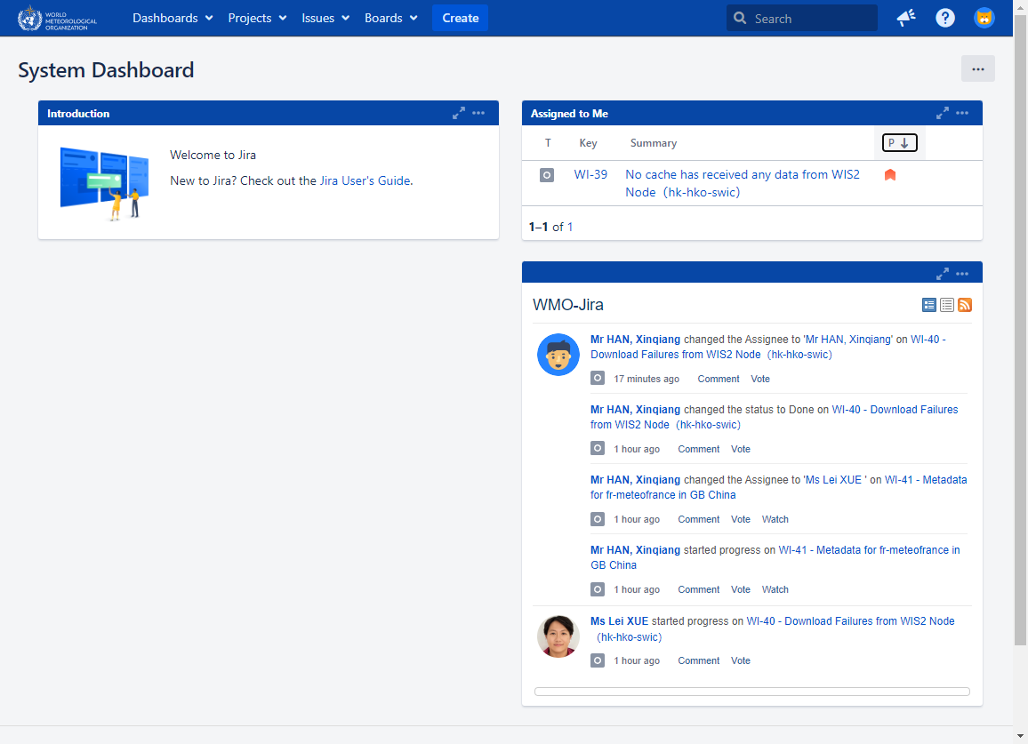After login, you may find the issues assigned to you.

You can also find the your issue by clicking the **User profile->Boards->Only My Issues**.

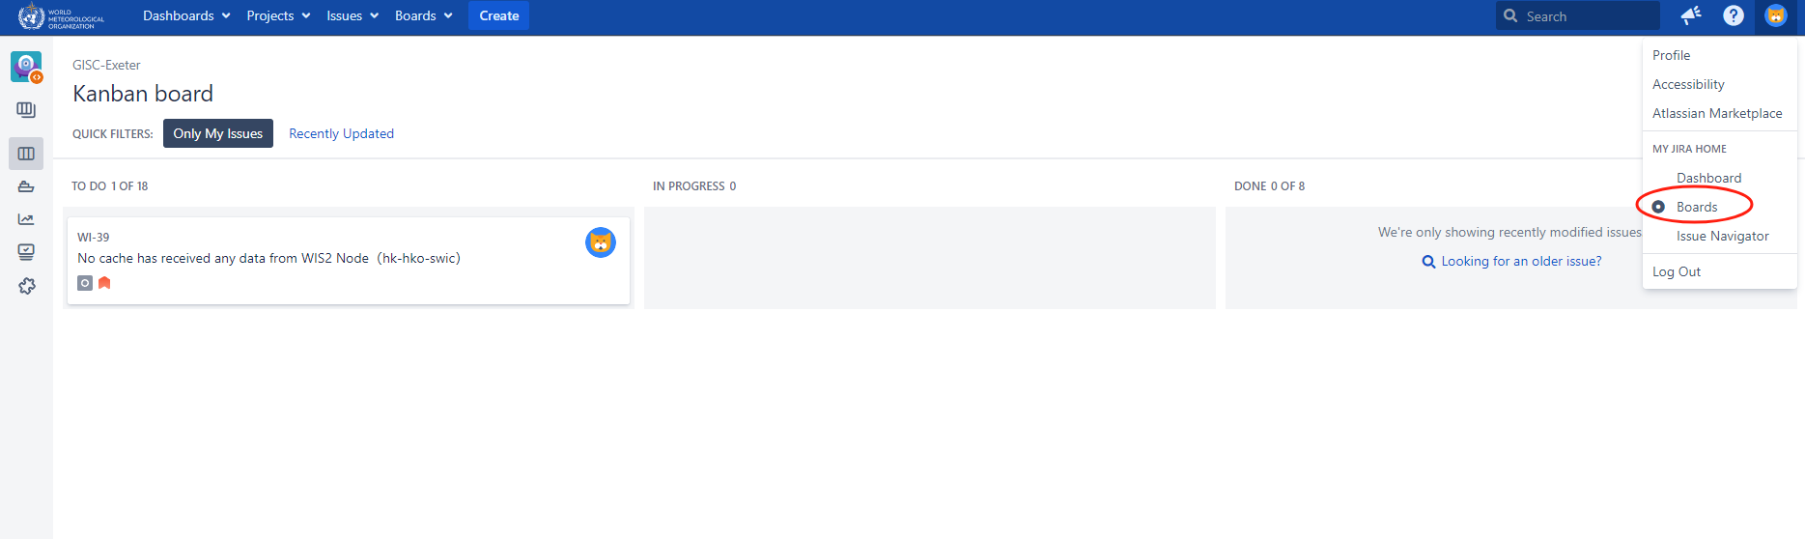

There is another way for you to find the entrance by clicking the **Issues** on the Menu, and **‘My open issues’** could be found on the left.

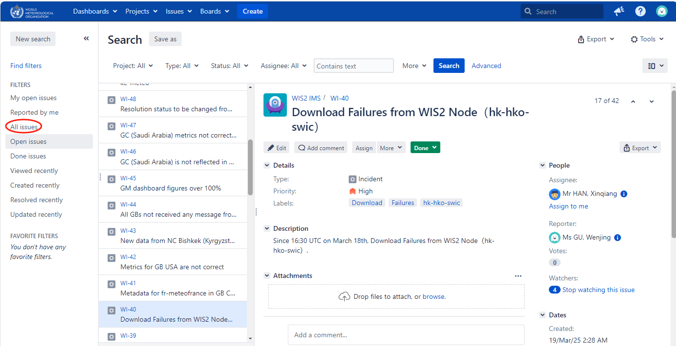

**Step 2:**

GISC Operator should check the issues , and then assign it to someone who is responsible for handling the issue(e.g. HAN Xinqiang) and the issue status will be set from ‘Triage’ to ‘TO DO’

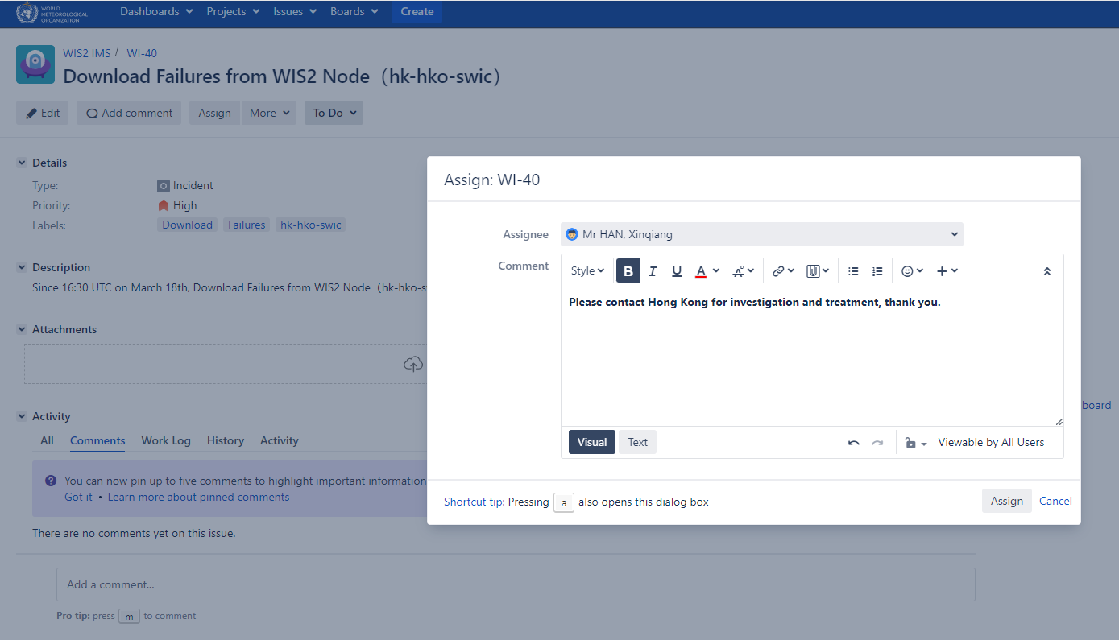

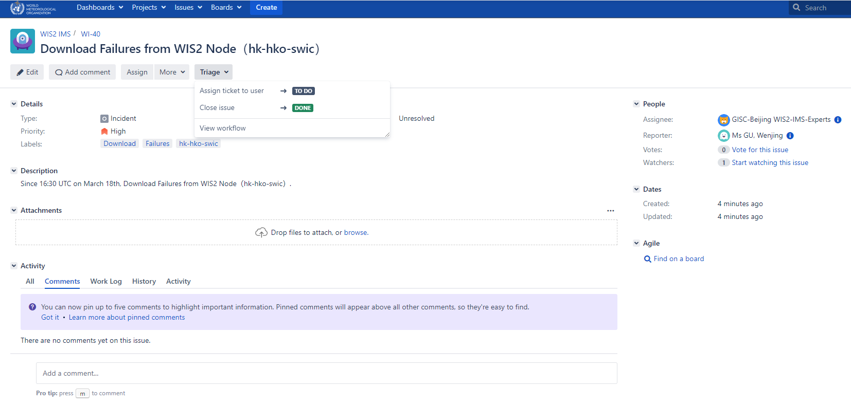

You can check the workflow by clicking **‘View workflow’**.

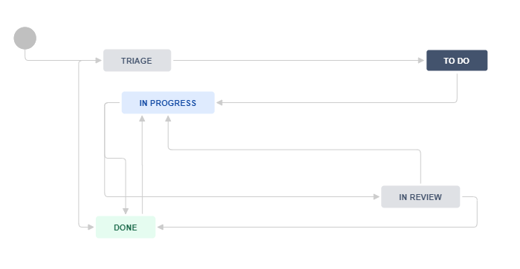

**Step 3:**

Assignee(HAN Xinqiang) starts working on issue, set issue status from ‘TO DO’ TO ‘IN PROGRESS’

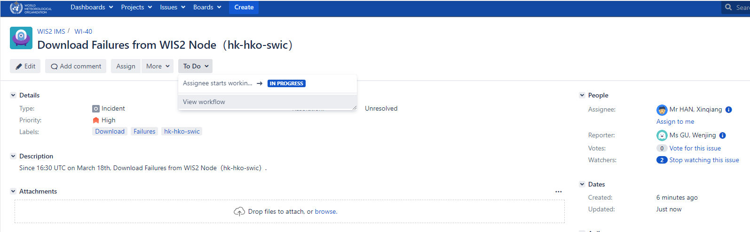

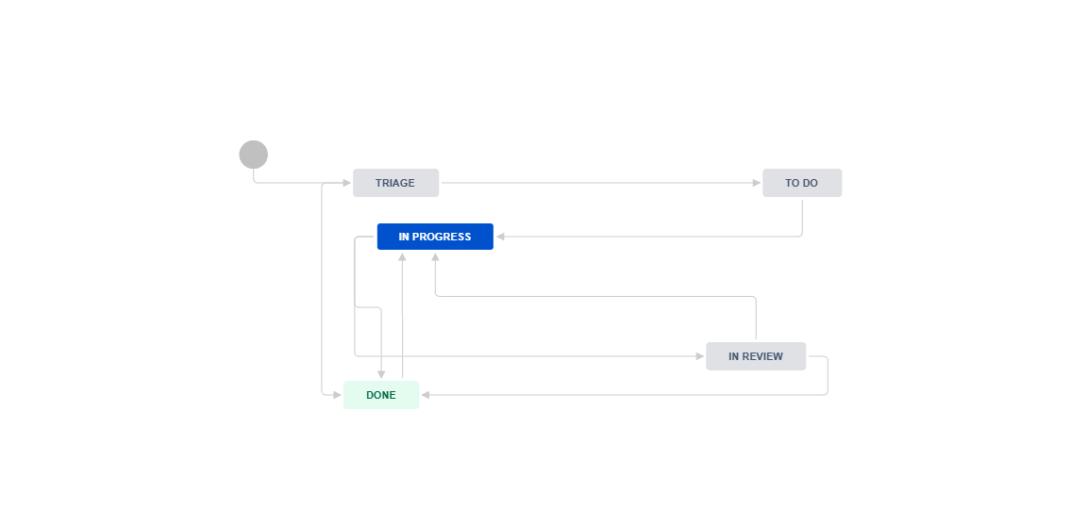

**Step 4:**

Assignee(HAN Xinqiang) finished dealing with the issue and submitted it to the leader for review ,set issue status from ‘IN PROGRESS’ to ‘ IN review’，and Assign this issue to the reviewer(XUE Lei).

You can see the process of issues in the comments below,and see the Reporter, Assignee, Watchers , etc. on the right.

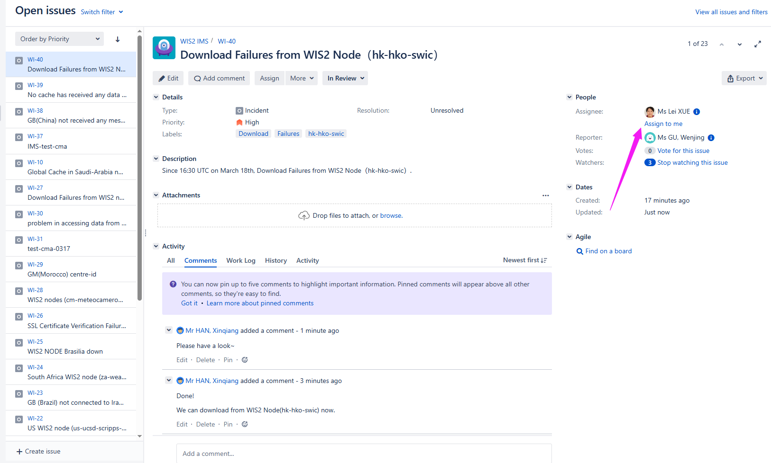

**Step 5:**

The reviewer(XUE Lei) reviewed the problem , assign it back to the issue handler(HAN Xinqian) , and set issue status from ‘In Review’ to ‘IN PROGRESS.

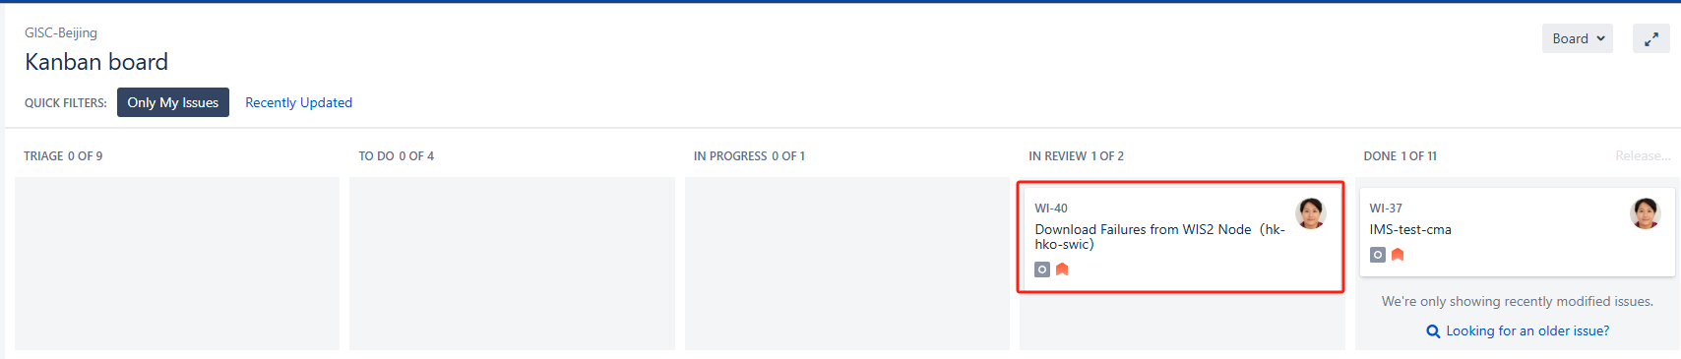

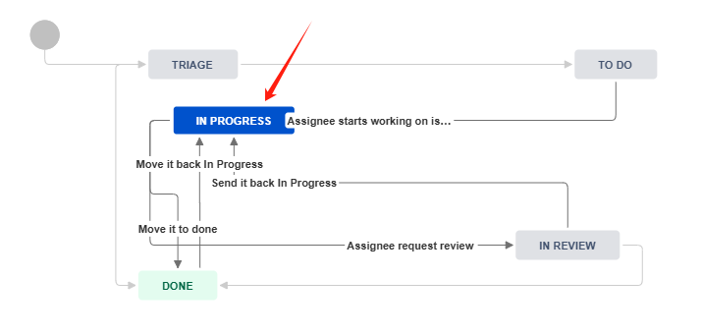

**Step 6:**

Assignee(HAN Xinqiang) receive feedback from the reviewer, and set issue status from‘IN PROGRESS’ to ‘DONE’, the issue has been successfully dealt with.

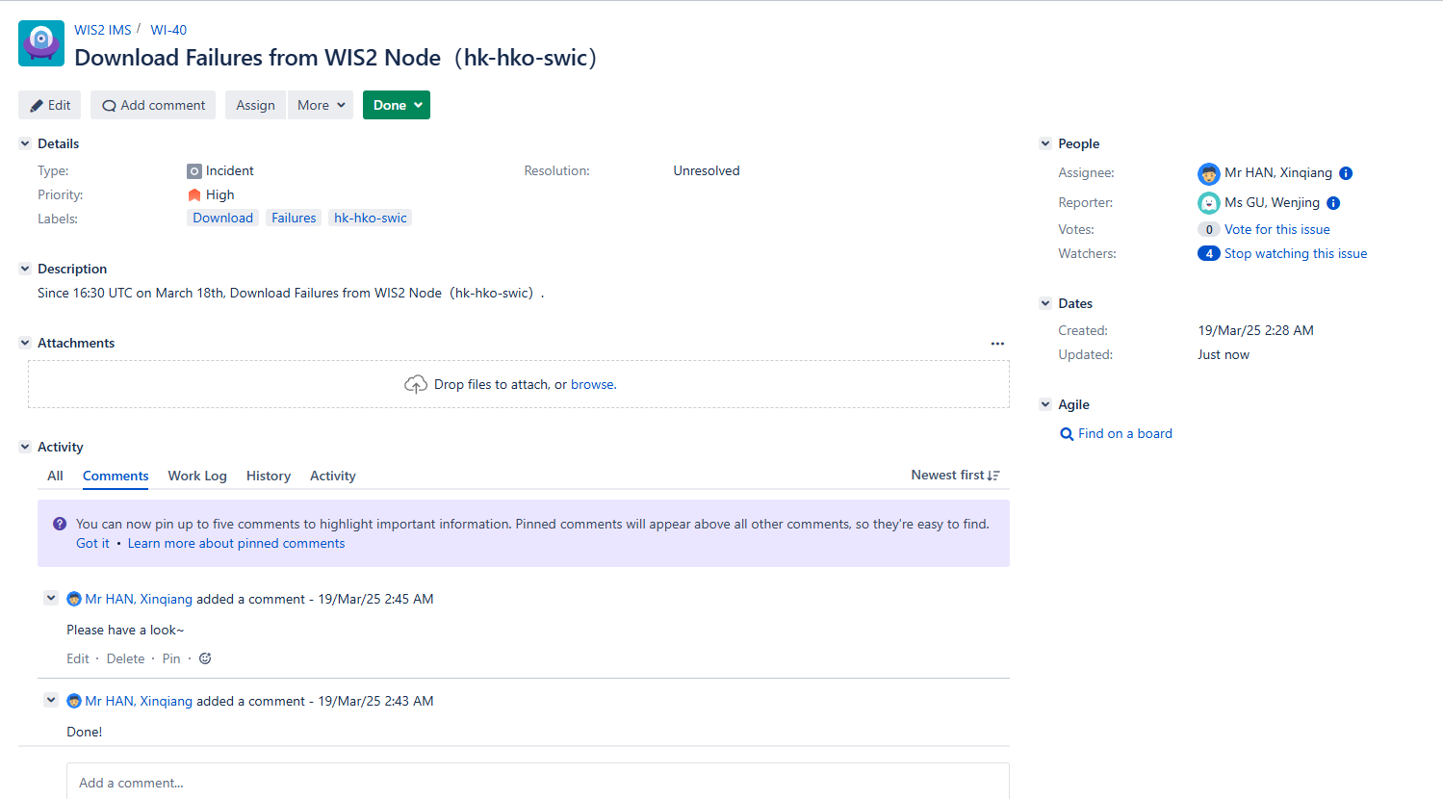

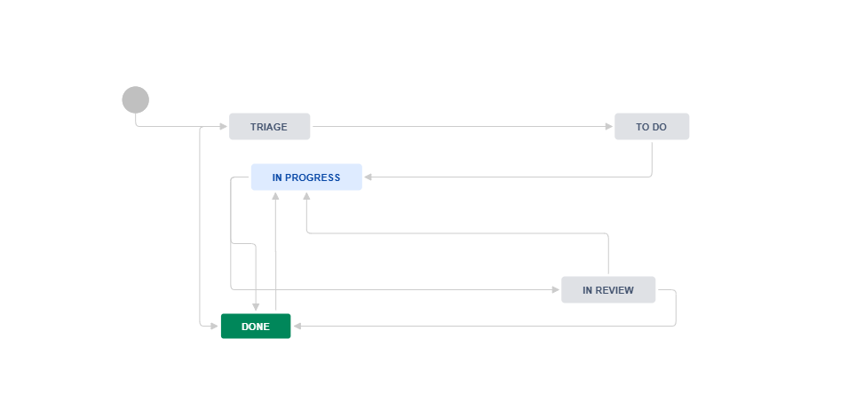

1. How to create issue

**Step 1:**

In the User interface section, select **Create**, and describe the problem in detail through graphics/text and set Priority, and then assign the issue to the relevant GISC.

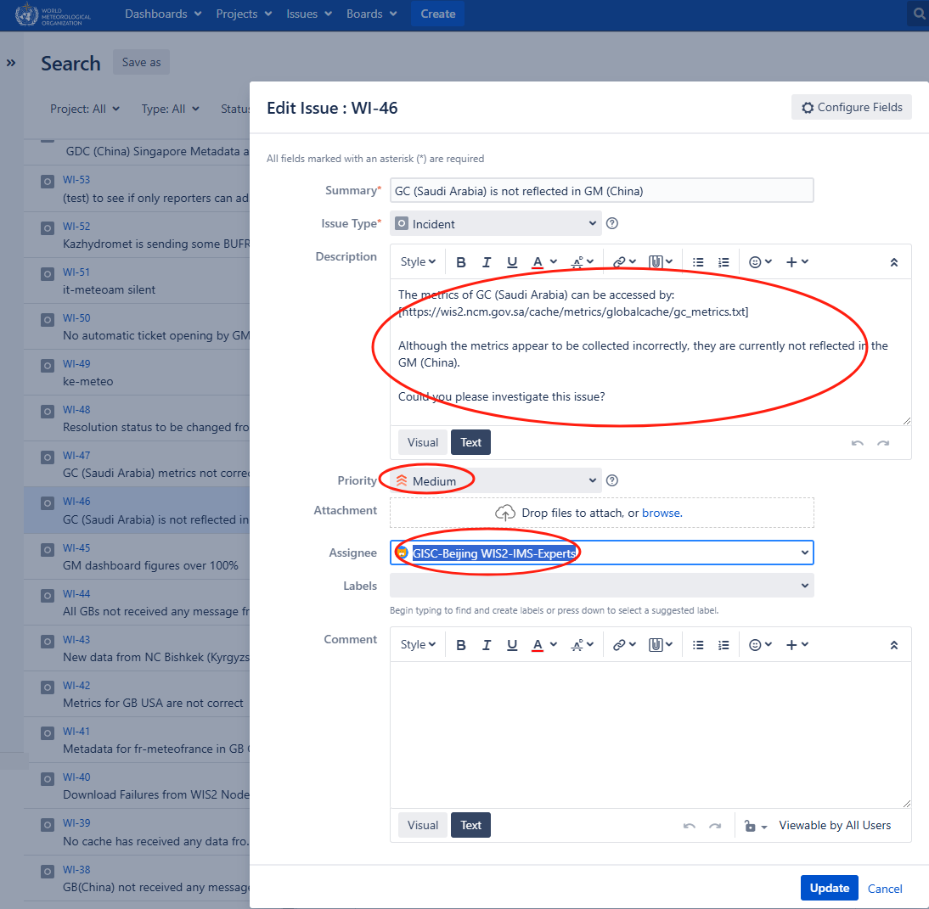

**Step 2:**

Add a comment to supplementary describe the issue

